How to effectively spend our marketing dollars

Problem Statement
BlueShield of California is in the healthcare insurance business. We sell insurance in 3 main markets.
- Individual & Family Plan (IFP)
- Employer based
- Medicare
- Small & medium businesses
With Obamacare we have seen a huge uptick in the IFP business. The IFP business has 2 primary channels
- Covered California- The state exchange website
- BlueShield’s Sales Portal

Covered California – The state of California has setup an online health insurance exchange where insurance companies like BSC & Kaiser compete for Californians business. Once a buyer picks a plan offered by one the insurers, the user is taken to the insurer’s website to complete the purchase. The sales process also determines if the buyer is subsidy eligible & applies the subsidy discount to the final cost. Plans offered on the exchange adhere to one of the metal levels that offer different levels of coverage & different sets of benefits. For e.g. Bronze metal plans offer the least amount of coverage and are some of the cheapest plans offered on the exchange site while platinum plans are one of the most expensive & hence offer one of the most comprehensive set of benefits.
BlueShield’s Sales Portal a.k.a Off Exchange– is BSC owned portal to sell insurance.
The IFP business is a cyclical business which starts with Open Enrollment usually in the last quarter of the year and extends till the 1st quarter of the following year. We sell our insurance either directly to our consumers or through brokers.

Scope Statement
The goal of this project is to analyze sales data obtained for the BlueShield Portal from Nov 2014 – March 2014, apply machine learning to look for correlations between the different data attributes & make recommendations around how to spend our marketing dollars for the Open Enrollment next year.

Organization of Data
The data has been obtained in excel format. Data is split between 2 tabs.
Tab1: Data from 3/16 - 200 records
Tab2: Nov 15- 2014 – March 1st - ~ 80K records
I plan to use Tab2 for most of my machine learning experiments. Tab2 can be used as an OOS dataset to check for generalization errors
Here are the set of data elements & their brief description
Gender
Age
Zip
Region – We divide the entire states into regions. We club zip codes to form regions. In some instances the business rules can be applied at a county level as well
PlanName – The name of the plans we sell in the IFP market on our sales portal.
languageDesc – Primary language spoken as identified the online application
Channel – Broker or direct to consumer
AppSubmitDate – The day the app was submitted
Purchase – Metal Level
consumer_id – If consumer id > 1 then it is a family
Application Type – We try to identify if the prospective customer is try to buy medical only plan or medical with dental or a special medical plan

Here are some of the insights the business owner for the Sales portal seem to be interested in:

By Zip, region or county, who is shopping? Can start w zip.
- Family vs. Individual
- Individual: Age range
- Family demo (i.e. 3 kids) within age range x
- What demo is picking which plan?
- What demo is picking which payment option?
Based on log in data, can we tell if folks are starting applications then abandoning them? Can we tell if they are starting, picking a plan, abandoning, then coming back in to pick a different plan?
How long does it take for a family vs. individual to apply? Where are prospects getting stuck?
What can we deduce? Example, Families in LA county (zip 90210) are picking Platinum plans & Individuals are picking the Bronze plan. Comparatively, they’re able to apply in about the same approximate time.

Approach : I started with some box plots & Violin plots (thanks Matt!!) to plot age v/s the plans prospects are buying.

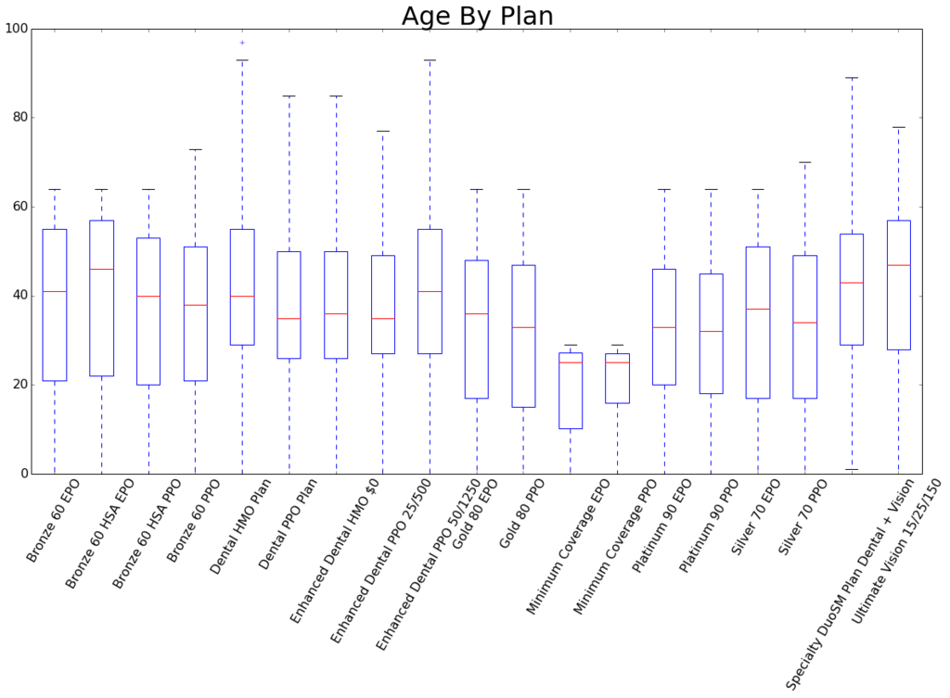

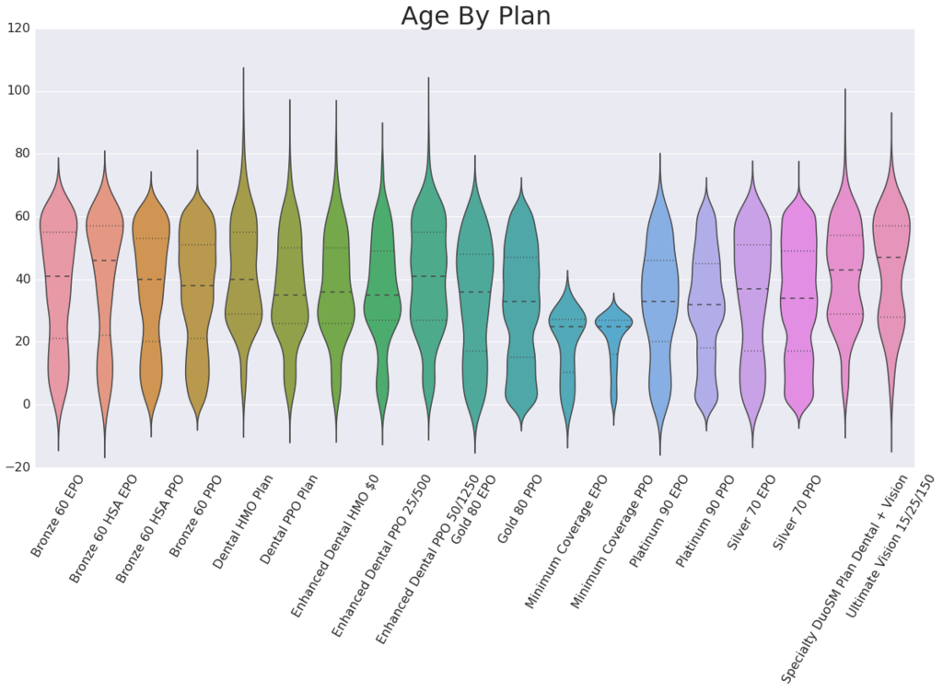
I plan to use focus most of my analysis around zip codes to try to answer questions that the sales portal owner has

By Zip, region or county, who is shopping?
- Family vs. Individual
Step 1 :change the family data into a classifier by applying the following logic:
If consumer_id > 1 then it’s a family otherwise it’s a single who bought the insurance
Step 2 :We then apply unsupervised categorical Algorithm : X is all attributes except consumer_id. Y is consumer_id
- Individual: Age range
Step 1: Divide Age into age groups 0-18, 18-26, 26-65, 65 and older
Question: If we divvy up age that way will it still be considered continuous?
Step 2: Apply unsupervised categorical Algorithm: X is all attributes except age. Y is age
- Family demo (i.e. 3 kids) within age range x
- What demo is picking which plan?
- What demo is picking which payment option?

Code in ipython notebook:
1.
# Running knn classifier to see if there a corelation between input attributes & metal level purchased
# running Knn Classifier with number of neighbours between 100 & 200
# Loop through each neighbors value from 1 to 51 and append
# the scores
# n_neighbors=5, weights='uniform', algorithm='auto', leaf_size=30, p=2, metric='minkowski', metric_params=None, **kwargs
# Various variables we'll need to set intially.
# RESULTS ARE PRETTY BAD with a best 37% accuracy
2.

# Cross Validation
# Loop through each neighbors value from 1 to 51 and append
# the scores
# n_neighbors=5, weights='uniform', algorithm='auto', leaf_size=30, p=2, metric='minkowski', metric_params=None, **kwargs
# Various variables we'll need to set intially.
# Results are no better with cross validation

3.
Some of the algorithms that I ran calculate some of the correlations described above. For e.g : # Calculate the correlation between zip & family i.e which zips are buying most family plans v/s individual plans
4.
# Calculate the corealtion between zip & plan name i.e which zips are buying what plans

